2013 Annual Report to
the School Community

Manifold Heights Primary School - School Number: 4224

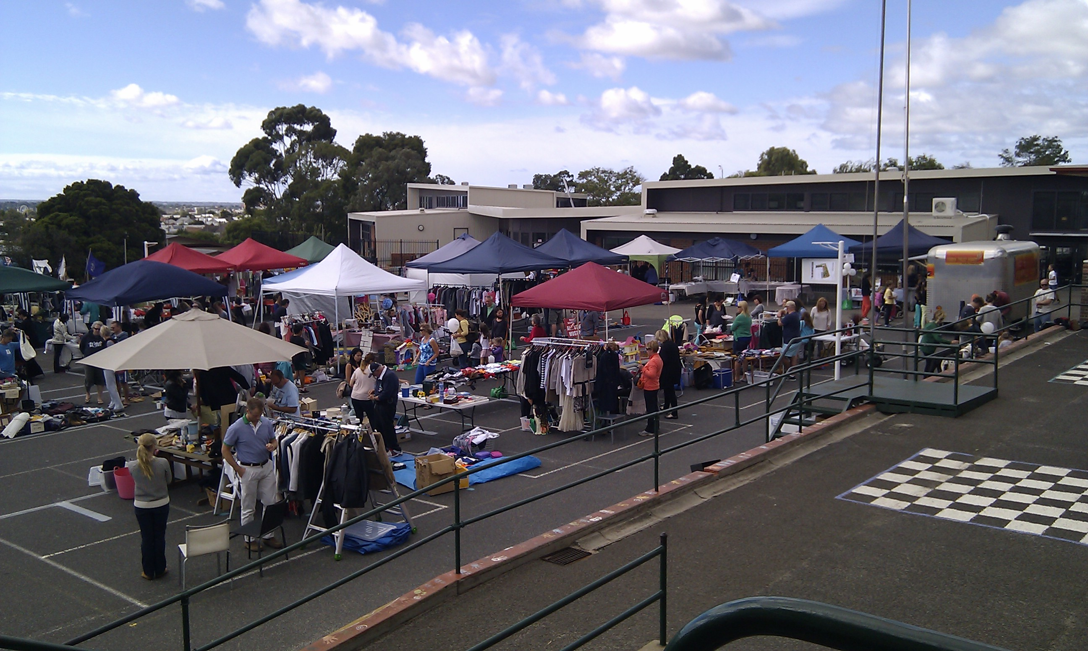
Name of School Principal:

Name of School Council President:

Date of Endorsement:

This school meets prescribed minimum standards for registration as set down by the Victorian Registration and Qualifications Authority (VRQA) in accordance with the Education and Training Reform Act 2006, inclusive of those schools granted an exemption by the VRQA under minimum standard 2.1 ‘Student enrolment numbers’ and/or 3.1 ‘Curriculum framework – languages program’ until 31 December 2013.

About Our School

Manifold Heights Primary School has a very positive and supportive environment in which everyone is encouraged to work towards our school motto – Unleashing Potential. Staff work in close partnership with parents to create an effective environment to cater for the children’s academic, social, physical and emotional development. Our staff are committed to continuous improvement and achieving excellence in teaching and learning at every level. Our programs cater for the individual needs of a diverse range of students through the use of Student Learning Goals linked closely to success criteria and explicitly stated learning intentions for class lessons.
We have an emphasis upon Inquiry Learning and allowing our students to develop their interests, skills and abilities. Critical and analytical thinking strategies combined with multi media equipment, Art, Music, History, Environmental Science, PE, Library and Indonesian gives us a curriculum which is varied, flexible and designed to meet students' individual needs.
By seeking comment and feedback we have tried to ensure that the views of staff, parents and students are always considered. We aim to build strong partnerships between parents and staff, and encourage a high level of parent participation through classroom helpers, volunteers in the grounds, focus groups, fundraising and social activities.
We offer our 368 students an attractive, safe and stimulating envrionment and a successful Before and After School Care facility. Our new building houses a fabulous Prep centre, along with new Art and Library facilities. Our Juniors work in a beautiful hertiage building, whilst our Middles and Seniors are housed in modern facilities with opportunties for team teaching and learning across multiple classes. We have EFT 24.3 staff – 20.1 teaching, 4.2 education support.

  Achievement
  Engagement
  Wellbeing
  The year culminated with our School Review in November giving us a wonderful opportunity to critically reflect on the past four years and set our targets and goals for our next Strategic Plan period.
  In the past year, achievement scores in student learning English and Mathematics show that we are performing at a higher level than other “like” schools we are compared to. Increasing the total number of students achieving an A or B score will continue to be a focus in our new Strategic Plan across all areas of English and Mathematics.
  As our student population continued to diversify, the number of students on our English as Another Language program increased and placed us in the Mid-High level range for the proportion of EAL students. An increase in the number of families accessing EMA has resulted in our SFO changing from 0.38 to 0.46 over the past five years.
  All our students are included in our performance measure scores including those on the Program for Students with Disabilities. These students achieved well when measured against their own individual goals and targets. Our Life Skills program supported and challenged our students across a range of activities and curriculum areas.
  Our results in the NAPLAN show our Yr3 and Yr 5 cohorts are performing at a similar level to our comparison schools in all areas except one. Our Yr 5 students achieved at a slightly lower level in numeracy when we look across a four year average.
  Our own school target to increase the amount of growth shown by each individual student continues to be part of our AIP as we extend and challenge our student’s learning across all areas.
  Building teacher capacity in differentiation, a focus on explicit feedback and feed forward, and extending our top performers (especially in numeracy) are our focus areas, targeted to improve student learning. These areas will form the basis of our Professional Development program in 2014.
  A review of our PLT processes, focusing on student misunderstandings in numeracy, and our involvement with the Australian Mathematics and Science Institute project will also help us to extend the relative gain of our students across 2014.
  Our student leadership program continued to be a feature of our school evolving each year to increase leadership opportunities for our students in key interest areas. Our School Captain and House Captain positions were again offered each term, along with opportunities as Planet Protectors, the Gardening team and as Art Buddies. Our Junior School Council led a social service activity each month including Red Cross, Heart Foundation, and Footy for Bushfires Day.
  The innovative program iTime continued to challenge students requiring them to take control of their own data and learning. For some students this required a huge adjustment and additional scaffolding to be put in place to support them.
  Embedding an Inquiry approach with additional student voice opportunities engaged students actively in their learning. An increase in the use and varied range of multi media equipment created authentic learning challenges to meet the needs of our students. The refinement of ipads into our program added possibilities to presentation and articulation of learning. The newly acquired notebooks also provided another way for students to present their learning. Different modes of multimedia will continue to be explored by the school.
  Our extra-curricular opportunities for students continued to strengthen with our school band – The PurrumBeatles, our School Singing Group, the Mano Dance Troupe, and being part of our State Schools Spectacular dance ensemble.
  The Queenscliff Bike Ride was once again a huge success with 90 parents participating in the two day event.
  Our student attendance is higher than the State average, however, data continues to reveal substantial absence due to family holidays and appointments during school hours. The school continues to follow up on unexplained absences and will continue to remind parents via the newsletter each week about the importance of school attendance.
  A record number of 18 parents participated in the Classroom Helpers Program during term two and went on to help in classrooms, especially in the Prep and Junior areas.
  The Mano Market was once again a successful community and fundraising event for our school. It’s growth and popularity is a credit to the School Council Fundraising and PR committee, and the many volunteers on the day.
  Our very successful Kids Hope program, along with the introduction of a Chaplain into our school two days per week works well and gives our students and families additional avenues to access the support they need.
  The expectation that students will engage in positive behavior ensures that bullying and intolerance are not accepted at this school, although the number and type of low level misdemeanors has not decreased over the past four years despite strategies being put in place.
  In addition to this, the increased number of students on the Autism Spectrum and/or with learning, social or emotional difficulties now attending our school, continued to challenge our thinking and approaches. In the past year all staff engaged in Professional Development in this area and will continue to work with parents, students and staff to achieve positive outcomes.
  Over the next three years, we will work with a mentor school on the School-Wide Positive Behaviour Strategy (SWPBS) program in order to address the issue we have identified. The development of a whole school matrix of the behavior we want to see from everyone associated with our school will come from this work. Our school community will also be invited to work with staff and School Council to review of our School Values to make sure they continue to be current and relevant to the outcomes we are aiming to achieve in our school.
  Our Attitudes to School survey completed by our students in Yrs 5 & 6 continues to show that our school scores at a comparable level to other schools in our “like” group.
  In 2013 students indicated that they were more satisfied with the Classroom behavior of their peers and felt safer than in previous years. Both these categories scored higher than the State.
  The areas of Student Motivation and Student Connectedness are two areas that we would like to focus on improving during 2014.
For more detailed information regarding our school please visit our website at
http://www.manifold.vic.edu.au, like us on facebook and join our Skoolbag app

  Performance Summary
The Government School Performance Summary provides an overview of how this school is performing and how it compares to all other Victorian government schools.

All schools work in partnership with their school community to improve outcomes for children and young people. Sharing this information with parents and the wider school community will foster engagement and collaboration to support further gains and positive learning experiences for all students.

School Profile

School Enrolments

A total of 368 students were enrolled at this school in 2013, 181 female and 187 male.

  Overall socio-economic profile
  Based on the school's Student Family Occupation index which takes into account parents' occupations.
  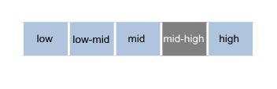
Proportion of students with English as a second language.

  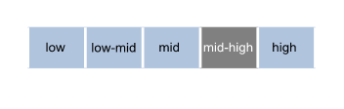
Parent Satisfaction Summary

Average level of parent satisfaction with the school, as derived from the annual Parent Opinion survey. The score is reported on a scale of 1 to 7, where 7 is the highest possible score.

  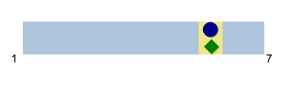
  Please note: The Staff Opinion Survey was not conducted in 2013.

  Performance Summary
  Achievement
  Student Outcomes
  School Comparison
  Teacher assessments from the Australian Curriculum/Victorian Essential Learning Standards (AusVELS)
  Percentage of students in Years Prep to 6 with a grade of C or above in:
  • English
  • Mathematics
  The grades are the same as those used in your child's end of year report.
  A 'C' rating means that a student is at the standard expected at the time of reporting.
  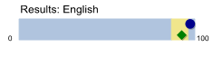
  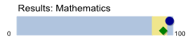
  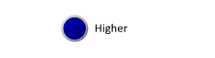
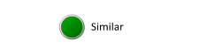
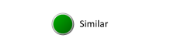

NAPLAN Year 3

Average score achieved on the NAPLAN Reading and Numeracy tests conducted in May each year.

Year 3 assessments are reported on a scale from Bands 1-6.

Bands represent different levels of achievement. For Year 3, the National Minimum Standard is at Band 2.

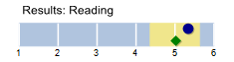
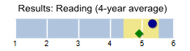
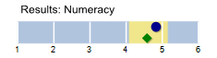
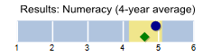

NAPLAN Year 5

Average score achieved on the NAPLAN Reading and Numeracy tests conducted in May each year.

Year 5 assessments are reported on a scale from Bands 3-8.

Bands represent different levels of achievement. For Year 5, the National Minimum Standard is at Band 4.

  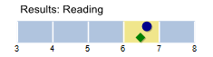
  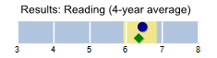
  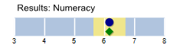
  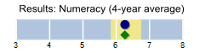
  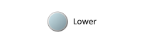

  Performance Summary
  Achievement
  Student Outcomes
  School Comparison
  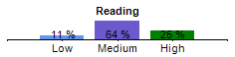
  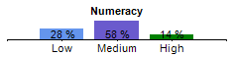
  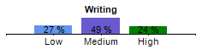
  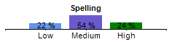
  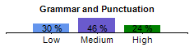
  NAPLAN Relative Growth does not require a School Comparison.
NAPLAN Relative Growth
Year 3 - Year 5

Relative gain of students from Year 3 to Year 5 in the following domains; Reading, Numeracy, Writing, Spelling and Grammar and Punctuation.

NAPLAN relative growth is determined by comparing a student's current year result to the results of all ‘similar’ Victorian students (i.e. students in all sectors in the same year level who had the same score two years prior). If the current year result is in the top 25%, their growth level is categorised as ‘High’, middle 50%, is ‘Medium’ and bottom 25%, is ‘Low’.

  Performance Summary
  Engagement
  Student Outcomes
  School Comparison
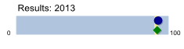
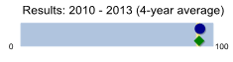
Prep | Yr1 | Yr2 | Yr3 | Yr4 | Yr5 | Yr6
93 % | 93 % | 93 % | 94 % | 95 % | 94 % | 92 %

  Student Attendance
  Average attendance rate of all students in the school. Common reasons for non-attendance include illness and extended family holidays.
  Average 2013 attendance rate by year level:
  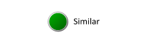

  Performance Summary
  Wellbeing
  Student Outcomes
  School Comparison
  Students Attitudes to School
  Derived from the Attitudes to School survey completed annually by Victorian government school students in Years 5 to 12. It includes questions about students' engagement in and enjoyment of school. The school's average score is reported here on a scale of 1 to 5, where 5 is the highest possible score.
  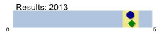
  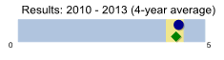

  How to read the Performance Summary 2013
  What are student outcomes?
  Student outcomes show the achievements of students in this school in English and Mathematics. They also show results in national literacy and numeracy tests and, for secondary colleges, the Victorian Certificate of Education (VCE) examinations. They provide important information about student attendance and engagement at school.
  For secondary colleges, the Performance Summary also provides information about how many students at this school go on to further studies or full-time work after leaving school.
  You can see these results for the latest year, as well as the average of the last four years (where available).
  The Performance Summary also allows you to compare student outcomes for students at this school with the outcomes of students in all other Victorian government schools.
  What is a School Comparison?
  The School comparison is a way of comparing school performance that takes into account the different student intake characteristics of each school.
  A School comparison takes into account the school’s academic intake, the socio-economic background of students, the number of Indigenous students, the number of non-English speaking and refugee students, the number of students with a disability, and the size and location of the school.
  The School comparison measures show that most schools are doing well and are achieving results that are ‘similar’ to what we would estimate given the background characteristics of their students. Some schools are doing exceptionally well with the students they have, and have ‘higher’ performance. Some schools have ‘lower’ performance after taking into account their students’ characteristics – these schools will receive targeted support to ensure that there is improvement.
 | 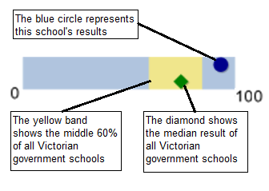
 |  |  |  |  | 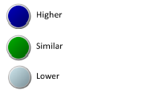
Looking at both the student outcomes and school
comparisons provides important information about what
a school is doing well and the areas that require further
improvement.

More information on school comparison performance
measures can be found at:
http://www.education.vic.gov.au/school/principals/manage
ment/pages/performreports.aspx

What is the meaning of ‘Data not available’?

For some schools, there are too few students to provide
data. For other schools, there are no students at some
levels, so school comparisons are not possible. Newly
opened schools have only the latest year of data and no
averages from previous years. The Department also
recognises the unique circumstances of Specialist, Select
Entry, English Language and Community Schools where
school comparisons are not appropriate.

What is this school doing to improve?

All schools have a plan to improve outcomes for their
students. The ‘About Our School’ statement provides a
summary of this school’s improvement plan.

Additionally, NAPLAN relative growth charts are provided for each of the NAPLAN domains. These compare a student's current year NAPLAN result to the results of all ‘similar’ Victorian students (i.e. students in all sectors in the same year level who had the same NAPLAN score two years prior).

If the current year result is in the top 25% their growth level is categorised as ‘High’, the middle 50% is categorised as ‘Medium’ and the bottom 25% is categorised as ‘Low’.

 | 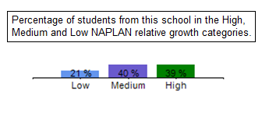

Financial Performance and Position

  Financial Performance - Operating Statement
  Summary for the year ending 31st December, 2013
  Financial Position as at 31st December, 2013
  Revenue | Actual
  Government Provided DE&T Grants | $564,482
  Government Grants Commonwealth | $7,242
  Government Grants State | $1,000
  Revenue Other | $14,103
  Locally Raised Funds | $185,861
  Total Operating Revenue | $772,688
  Funds Available | Actual
  High Yield Investment Account | $89,931
  Official Account | $16,655
  Other Accounts | $340,970
  Total Funds Available | $447,556
  Expenditure
  Books & Publications | $9,510
  Communication Costs | $6,655
  Consumables | $68,564
  Miscellaneous Expense | $96,531
  Professional Development | $10,107
  Property Maintenance | $224,678
  Salaries & Allowances | $107,362
  Trading & Fundraising | $23,724
  Utilities | $27,121
  Total Operating Expenditure | $574,254
  Financial Commitments
  Operating Reserve | $78,113
  Capital - Buildings/Grounds incl SMS<12 months | $196,959
  Maintenance - Buildings/Grounds incl SMS<12 months | $19,756
  Revenue Receipted in Advance | $63,765
  Repayable to DEECD | $68,258
  Asset/Equipment Replacement > 12 months | $20,704
  Total Financial Commitments | $447,556
  Net Operating Surplus/-Deficit
  $198,434
Asset Acquisitions

  $0
Please note that the above amounts do not include any credit revenue or expenditure allocated or spent by the school through its Student Resource Package.

Misc Expenses may include Bank charges, Health and Personal Development, Administration charges, Camp/Excursion costs and Taxation charges.

  For consistency across Financial reporting, the Capital Expenditure label from previous reports now appears as Asset Acquisitions.
Financial performance and position commentary

